Research Report I

[UNIVERSITY ALUMNI PORTAL]

Final Year Project – I

(CS-609)



Supervisor
[Sir Dr. Qamar Nawaz]
Submitted by
[Rahat Kanwal]
[2022-ag-7874]

BS [Computer Science]
Department of Computer Science University of Agriculture, Faisalabad.

INDEX / TABLE OF CONTENTS

- Introduction
  - Background ----------------------------------------------------------------------------------- 3
  - Description ----------------------------------------------------------------------------------- 3
  - Scope ----------------------------------------------------------------------------------------- 4
  - Objectives ------------------------------------------------------------------------------------- 5
- Requirements
  - Functional Requirements ------------------------------------------------------------------ 6
  - Non-Functional Requirements ------------------------------------------------------------ 6
  - Hardware Requirements ------------------------------------------------------------------- 7
    - Web Server Hardware ------------------------------------------------------------------- 7
    - Database Server Hardware ------------------------------------------------------------- 7
  - Software Requirements -------------------------------------------------------------------- 7
- Methodology
  - Requirement Analysis and Planning ---------------------------------------------------- 8
  - System Design -------------------------------------------------------------------------------- 8
  - Development ---------------------------------------------------------------------------------- 8
  - Testing and Security ------------------------------------------------------------------------ 9
  - Deployment and Maintenance ------------------------------------------------------------ 9
- Tools & Technologies
  - Frontend Technologies --------------------------------------------------------------------- 9
  - Backend Technologies ---------------------------------------------------------------------- 9
  - Hosting and Security ------------------------------------------------------------------------ 9
- Project Timeline ---------------------------------------------------------------------------------- 10
- Conclusion ----------------------------------------------------------------------------------------- 10

INTRODUCTION
1.1 Background:
The University Alumni Portal is a web-based system designed to strengthen the connection between the University of Agriculture, Faisalabad (UAF) and its alumni network. In today's digital age, maintaining meaningful relationships with former students has become crucial for institutional growth, networking opportunities, and fostering a sense of community. Traditional methods of alumni engagement, such as periodic newsletters or occasional reunions, are no longer sufficient to meet the expectations of modern graduates who seek continuous interaction and professional networking opportunities. The concept of an alumni portal addresses the growing need for a centralized digital platform where former students can reconnect with their alma mater, maintain their professional profiles, participate in university events, share career achievements, and contribute to the current student body through mentorship programs. This initiative recognizes that alumni are valuable assets to any educational institution, serving as ambassadors, potential employers, mentors, and contributors to institutional development. The development of this portal aligns with the university's mission to modernize its engagement strategies and leverage technology to build stronger connections with its graduate community. By providing a secure, user-friendly, and feature-rich platform, the University Alumni Portal aims to create a sustainable ecosystem that benefits both the institution and its alumni members.
1.2 Description:
The University Alumni Portal follows a modular architecture where each functional module (User Management, Alumni Profiles, Events Management, News/Announcements, and Administrative Dashboard) interacts seamlessly through a robust backend PHP layer. The system is designed with security and scalability as primary considerations, utilizing SQL databases with prepared statements to prevent SQL injection attacks and ensure data integrity. The system implements a conceptual MVC (Model-View-Controller) design pattern for code organization and maintainability. This architectural approach separates business logic from presentation, making the codebase more organized, testable, and easier to maintain. The Model layer handles database interactions, the View layer manages the user interface presentation, and the Controller layer processes user requests and coordinates between models and views. All users interact through a clean, responsive web interface styled with modern CSS and enhanced with JavaScript for dynamic functionality. The interface is designed to be intuitive and accessible across multiple devices, ensuring that alumni can access the portal from desktops, tablets, and smartphones with equal ease. The system supports two primary user roles: Alumni members who can manage their profiles and participate in community activities, and Administrators who oversee system operations, manage content, and maintain the platform.
1.4 Scope:
The scope of the University Alumni Portal focuses on delivering essential features required for efficient alumni management and engagement. The system includes the following major functionalities:
- Secure alumni registration and login
- Alumni profile creation and management
- Alumni directory with search and filtering options
- Event management and announcements
- Administrative dashboard for user and content management
- Secure database management and session handling
- Responsive design for multi-device accessibility
The system is designed with scalability in mind, allowing future enhancements such as job portals, mentorship programs, analytics dashboards, and mobile application integration.

1.5 Objectives:
The main objectives of the University Alumni Portal are:
- To develop a centralized web-based system for managing alumni information
- To improve communication between alumni and the university
- To provide a secure platform for alumni registration and authentication
- To allow administrators to manage alumni data, events, and announcements
- To offer a responsive and user-friendly interface
- To ensure data security and system reliability
1.6 Feasibility
1.6.1 Technical Feasibility – The project is technically feasible as it utilizes well-established and widely-supported technologies. Core PHP is an open-source server-side scripting language with extensive documentation and community support. SQLite provides a lightweight database solution that can be easily migrated to MySQL for production scalability. The development environment (XAMPP) is freely available and provides all necessary components (Apache web server, PHP, and database support). The development team has access to the required technical resources and knowledge base to implement the proposed system.
1.6.2 Schedule Feasibility – The project timeline spans two semesters (7th and 8th), providing adequate time for requirement analysis, system design, implementation, testing, and documentation. The 7th semester focuses on planning and partial implementation (40% completion), while the 8th semester is allocated for full development, testing, and deployment. This timeline is realistic and achievable given the scope of the project.
1.6.3 Economic Feasibility – The project is economically feasible as it primarily uses open-source technologies that require no licensing costs. The development environment (XAMPP) is free, and hosting can be achieved through university servers or low-cost web hosting services. The only significant costs would be related to domain registration (if required) and hosting services, which are minimal. The benefits of improved alumni engagement and networking opportunities far outweigh the minimal costs involved.
1.6.4 Cultural Feasibility – The system promotes positive cultural values by strengthening university-alumni relationships and fostering a sense of community. It provides a platform for professional networking, mentorship opportunities, and knowledge sharing, all of which align with educational and professional development goals. The system respects user privacy and data protection, ensuring cultural acceptance and trust.
1.6.5 Legal/Ethical Feasibility – The project adheres to legal and ethical standards by implementing robust security measures including password hashing, secure session handling, and input validation. User data privacy is protected through secure authentication mechanisms. The system complies with data protection principles and ensures that user information is handled responsibly. All content management features include appropriate access controls to prevent unauthorized modifications.
1.6.6 Resource Feasibility – The project requires minimal hardware resources: a standard development computer with internet connectivity. Software requirements are met through freely available tools (XAMPP, code editors, browsers). The development team has access to university computing facilities and necessary software licenses. Database storage requirements are modest and can be accommodated on standard hosting platforms.
1.6.7 Operational Feasibility – The system is designed to be user-friendly and intuitive, requiring minimal training for both administrators and alumni users. The responsive design ensures accessibility across various devices and platforms. The modular architecture allows for easy maintenance and future enhancements. The system can be easily integrated into the university's existing IT infrastructure with minimal disruption to current operations.
Requirements
2.1 Functional Requirements
The system provides essential functionalities required for alumni and administrators. Alumni can register, log in, manage their profiles, and view other alumni through the directory. The system allows searching alumni by various criteria such as name, department, and graduation year. Administrators can manage users, publish events, and post news or announcements. Secure session handling ensures that only authenticated users can access system features.
2.2 Non-Functional Requirements
The University Alumni Portal is designed to be reliable, secure, and efficient. The system ensures availability for users at all times and maintains fast response times under normal usage conditions. Security measures such as password hashing, prepared SQL statements, and input validation are implemented to protect user data. The system also supports scalability to handle an increasing number of users and records.
2.3 Hardware Requirements
Web/Application Server Hardware:
- Processor: Intel Core i3 or higher
- RAM: 4 GB or more
- Storage: Minimum 40 GB
- Internet Connectivity: Required

Client Hardware:
- Desktop, laptop, tablet, or smartphone
- Display resolution of at least 1024×768
2.4 Software Requirements
- Operating System: Windows, Linux, or macOS
- Web Server: Apache (XAMPP Environment)
- Backend Language: PHP 7.4 or higher
- Database: SQLite or MySQL
- Web Browser: Google Chrome, Mozilla Firefox, Microsoft Edge
- Frontend Technologies: HTML5, CSS3, JavaScript, Bootstrap
METHODOLOGY
The development of the University Alumni Portal follows the Agile methodology, which allows iterative development and continuous improvement.
Requirement Analysis and Planning: System requirements were gathered by analyzing university needs and alumni engagement challenges. Functional and non-functional requirements were defined during this phase.
System Design: The system architecture and database structure were designed to support modular development. UML diagrams and data flow models were prepared to visualize system behavior.
Development: Frontend development focused on creating a responsive and user-friendly interface. Backend development handled authentication, data processing, and database interactions.
Testing and Security: The system underwent functional, integration, and security testing. Measures such as SQL injection prevention, XSS protection, and secure session handling were implemented.
Deployment and Maintenance: The application is deployed on a local or web server environment. Regular maintenance ensures smooth operation and supports future enhancements.

TOOLS & TECHNOLOGIES
Frontend:
- HTML5
- CSS3
- JavaScript
- Bootstrap
Backend:
- Core PHP
Database:
- MySQL
Development Environment:
- XAMPP
- Web Browsers
- Code Editors
PROJECT TIMELINE
The University Alumni Portal project was initiated during the 7th semester as part of Final Year Project-I. Initial phases focused on requirement analysis, system design, and partial development. Approximately 40% of the system, including core features and interface design, has been completed. The remaining development, testing, and deployment activities are scheduled for the 8th semester under Final Year Project-II.
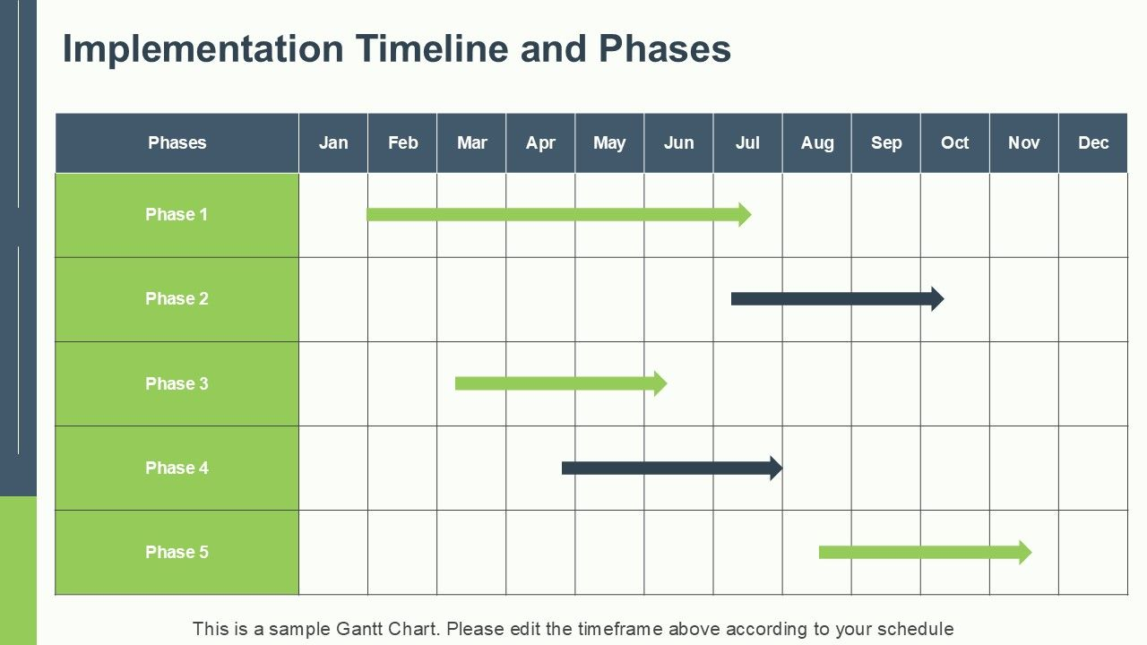
6. CONCLUSION
The University Alumni Portal provides a modern and efficient solution for managing alumni information and strengthening relationships between the university and its graduates. By offering secure authentication, profile management, alumni search, and administrative control, the system addresses the limitations of traditional alumni management methods. The portal improves communication, enhances alumni engagement, and supports institutional growth. Overall, the system is scalable, secure, and user-friendly, making it a valuable digital asset for the University of Agriculture, Faisalabad.

